Example of Solutions to Mathematical Word Problems Done by the Teacher
On the following two pages are examples of physics problems that I worked out myself and then posted these solutions on Google Classroom for an advanced, college-level physics class. I typically assigned about three to six problems per week for students to do as homework, and I usually assigned them early in the week and made them due at the end of the week. My solutions would appear on Google Classroom the evening before they were due so that students could check their solutions against mine.
I only graded a student’s completion of these problems, and I awarded a small number of points for such assignments. In this way, students had a few days to complete the problems, and they did not feel stressed enough about them to cheat on them. Because the majority of test questions were similar problems, students learned quickly that they needed to do practice problems and ask questions if they had trouble with them.
Early in my teaching career, I tried asking students in class if they needed help, then I would take class time to solve a problem on the board. However, I found that this was a bad teaching practice because I realized I was wasting class time to help a small number of students. Many students did not need help, so they sat there bored while I solved the problem. Therefore, over time and with much experimentation, I found this technique of posting my solutions on Google Classroom to be much more effective. It helped all students improve their problem solving ability because they all could check their solutions at their own pace. I asked students to correct their problems in a different color of ink after they looked at my solutions, and in posting these corrected problems, students learned much better than just watching me solve a problem on the board.
Please note that on the next two pages, the questions are taken from Chapter 3 of the textbook, Cutnell and Johnson Physics, Edition 10e, David Young and Shane Stadler, Wiley, 2015. These were problems on two-dimensional motion, a notoriously difficult topic for many students, so I tried to model a clear, effective, step-by-step process to solve them.
First example:
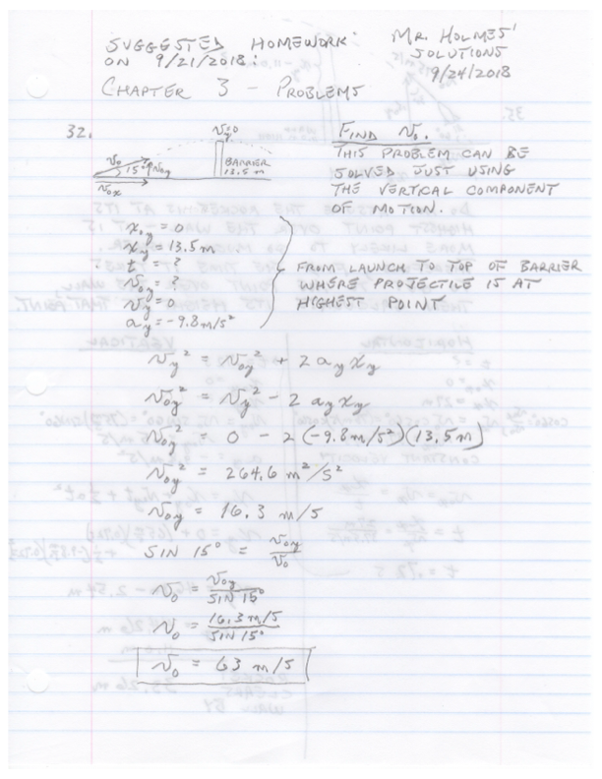
Second example: Problem #35
